LAPORAN PROYEKSI KALKULUS



KELOMPOK 2

1. Fawwaz Ivandra ( M0520030 )

2. Irfan Jalal Hibban ( M0520039 )

3. Muhammad Alwiza Ansyar ( M0520051 )

4. Muhammad Fahlevi Ramadhan ( M0520053 )

UNIVERSITAS SEBELAS MARET SURAKARTA

TAHUN 2020 / 2021

BAB 1 PENDAHULUAN

1.1 Latar belakang Masalah

1.2 Rumusan Masalah

1.3 Tujuan Penulisan

1.4 Manfaat Penulisan

BAB 2 PEMBAHASAN

2.1 Penjesalan Data

Data yang diambil di dalam pecobaan ini adalah data pasien Covid-19 di Kota Surabaya. Data tersebut mencangkup konfirmasi di dalam perawatan, konfirmasi pasien yang sembuh dari penyakit Covid-19 dan konfirmasi pasien yang meninggal karena penyakit ini. Di dalam data ini juga melingkup semua kasus Covid-19 di seluruh penjuru Kota Surabaya. Tetapi di dalam percobaan ini kelompok kami hanya mengambil satu data sembuh covid-19 di Kota Surabaya. Berikut ini adalah grafik data yang kami ambil dari laman website yang bersumber <https://lawancovid19-surabaya.go.ig/visualisasi/graph>.

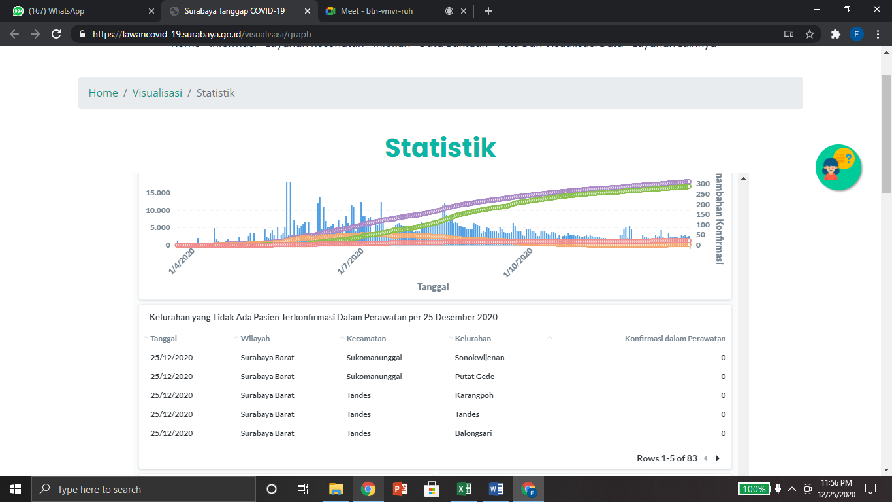

Setelah mengunduh data dari lama tersebut, kemudian kami memindahkan nya ke dalam Microsoft excel dan hanya di ambil berupa data pasien yang sembuh dari penyakit Covid-19 Kota Surabaya.

|  |  |  |
| --- | --- | --- |
| i | Tanggal (xi) | Total sembuh (yi) |
| 0 | 24-Mar | 0 |
| 1 | 25-Mar | 0 |
| 2 | 26-Mar | 5 |
| 3 | 27-Mar | 5 |
| 4 | 28-Mar | 5 |
| 5 | 29-Mar | 7 |
| 6 | 30-Mar | 10 |
| 7 | 31-Mar | 11 |
| 8 | 1-Apr | 11 |
| 9 | 2-Apr | 11 |
| 10 | 3-Apr | 14 |
| 11 | 4-Apr | 17 |
| 12 | 5-Apr | 21 |
| 13 | 6-Apr | 23 |
| 14 | 7-Apr | 23 |
| 15 | 8-Apr | 25 |
| 16 | 9-Apr | 27 |
| 17 | 10-Apr | 32 |
| 18 | 11-Apr | 33 |
| 19 | 12-Apr | 35 |
| 20 | 13-Apr | 39 |
| 21 | 14-Apr | 39 |
| 22 | 15-Apr | 40 |
| 23 | 16-Apr | 43 |
| 24 | 17-Apr | 45 |
| 25 | 18-Apr | 45 |
| 26 | 19-Apr | 45 |
| 27 | 20-Apr | 45 |
| 28 | 21-Apr | 46 |
| 29 | 22-Apr | 51 |
| 30 | 23-Apr | 61 |
| 31 | 24-Apr | 65 |
| 32 | 25-Apr | 70 |
| 33 | 26-Apr | 72 |
| 34 | 27-Apr | 73 |
| 35 | 28-Apr | 75 |
| 36 | 29-Apr | 79 |
| 37 | 30-Apr | 81 |
| 38 | 1-May | 81 |
| 39 | 2-May | 84 |
| 40 | 3-May | 84 |
| 41 | 4-May | 86 |
| 42 | 5-May | 88 |
| 43 | 6-May | 91 |
| 44 | 7-May | 91 |
| 45 | 8-May | 99 |
| 46 | 9-May | 100 |
| 47 | 10-May | 106 |
| 48 | 11-May | 110 |
| 49 | 12-May | 115 |
| 50 | 13-May | 115 |
| 51 | 14-May | 121 |
| 52 | 15-May | 126 |
| 53 | 16-May | 130 |
| 54 | 17-May | 134 |
| 55 | 18-May | 140 |
| 56 | 19-May | 142 |
| 57 | 20-May | 154 |
| 58 | 21-May | 157 |
| 59 | 22-May | 158 |
| 60 | 23-May | 179 |
| 61 | 24-May | 179 |
| 62 | 25-May | 188 |
| 63 | 26-May | 193 |
| 64 | 27-May | 194 |
| 65 | 28-May | 199 |
| 66 | 29-May | 200 |
| 67 | 30-May | 200 |
| 68 | 31-May | 223 |
| 69 | 1-Jun | 240 |
| 70 | 2-Jun | 300 |
| 71 | 3-Jun | 540 |
| 72 | 4-Jun | 610 |
| 73 | 5-Jun | 742 |
| 74 | 6-Jun | 766 |
| 75 | 7-Jun | 812 |
| 76 | 8-Jun | 867 |
| 77 | 9-Jun | 923 |
| 78 | 10-Jun | 960 |
| 79 | 11-Jun | 998 |
| 80 | 12-Jun | 1188 |
| 81 | 13-Jun | 1228 |
| 82 | 14-Jun | 1269 |
| 83 | 15-Jun | 1300 |
| 84 | 16-Jun | 1331 |
| 85 | 17-Jun | 1376 |
| 86 | 18-Jun | 1426 |
| 87 | 19-Jun | 1487 |
| 88 | 20-Jun | 1559 |
| 89 | 21-Jun | 1595 |
| 90 | 22-Jun | 1631 |
| 91 | 23-Jun | 1670 |
| 92 | 24-Jun | 1838 |
| 93 | 25-Jun | 1968 |
| 94 | 26-Jun | 2068 |
| 95 | 27-Jun | 2118 |
| 96 | 28-Jun | 2238 |
| 97 | 29-Jun | 2314 |
| 98 | 30-Jun | 2425 |
| 99 | 1-Jul | 2543 |
| 100 | 2-Jul | 2737 |
| 101 | 3-Jul | 2791 |
| 102 | 4-Jul | 2890 |
| 103 | 5-Jul | 2930 |
| 104 | 6-Jul | 3006 |
| 105 | 7-Jul | 3071 |
| 106 | 8-Jul | 3143 |
| 107 | 9-Jul | 3219 |
| 108 | 10-Jul | 3320 |
| 109 | 11-Jul | 3395 |
| 110 | 12-Jul | 3477 |
| 111 | 13-Jul | 3580 |
| 112 | 14-Jul | 3705 |
| 113 | 15-Jul | 3840 |
| 114 | 16-Jul | 3974 |
| 115 | 17-Jul | 4104 |
| 116 | 18-Jul | 4236 |
| 117 | 19-Jul | 4284 |
| 118 | 20-Jul | 4389 |
| 119 | 21-Jul | 4432 |
| 120 | 22-Jul | 4494 |
| 121 | 23-Jul | 4593 |
| 122 | 24-Jul | 4638 |
| 123 | 25-Jul | 4695 |
| 124 | 26-Jul | 4733 |
| 125 | 27-Jul | 4798 |
| 126 | 28-Jul | 4899 |
| 127 | 29-Jul | 5001 |
| 128 | 30-Jul | 5121 |
| 129 | 31-Jul | 5244 |
| 130 | 1-Aug | 5381 |
| 131 | 2-Aug | 5496 |
| 132 | 3-Aug | 5597 |
| 133 | 4-Aug | 5707 |
| 134 | 5-Aug | 5822 |
| 135 | 6-Aug | 5932 |
| 136 | 7-Aug | 6039 |
| 137 | 8-Aug | 6166 |
| 138 | 9-Aug | 6308 |
| 139 | 10-Aug | 6438 |
| 140 | 11-Aug | 6569 |
| 141 | 12-Aug | 6680 |
| 142 | 13-Aug | 6855 |
| 143 | 14-Aug | 7075 |
| 144 | 15-Aug | 7305 |
| 145 | 16-Aug | 7515 |
| 146 | 17-Aug | 7727 |
| 147 | 18-Aug | 7914 |
| 148 | 19-Aug | 8109 |
| 149 | 20-Aug | 8309 |
| 150 | 21-Aug | 8501 |
| 151 | 22-Aug | 8631 |
| 152 | 23-Aug | 8751 |
| 153 | 24-Aug | 8861 |
| 154 | 25-Aug | 8968 |
| 155 | 26-Aug | 9083 |
| 156 | 27-Aug | 9193 |
| 157 | 28-Aug | 9306 |
| 158 | 29-Aug | 9471 |
| 159 | 30-Aug | 9533 |
| 160 | 31-Aug | 9653 |
| 161 | 1-Sep | 9768 |
| 162 | 2-Sep | 9885 |
| 163 | 3-Sep | 9989 |
| 164 | 4-Sep | 10049 |
| 165 | 5-Sep | 10124 |
| 166 | 6-Sep | 10229 |
| 167 | 7-Sep | 10329 |
| 168 | 8-Sep | 10433 |
| 169 | 9-Sep | 10508 |
| 170 | 10-Sep | 10623 |
| 171 | 11-Sep | 10693 |
| 172 | 12-Sep | 10765 |
| 173 | 13-Sep | 10830 |
| 174 | 14-Sep | 10920 |
| 175 | 15-Sep | 11005 |
| 176 | 16-Sep | 11080 |
| 177 | 17-Sep | 11150 |
| 178 | 18-Sep | 11330 |
| 179 | 19-Sep | 11520 |
| 180 | 20-Sep | 11670 |
| 181 | 21-Sep | 11815 |
| 182 | 22-Sep | 11925 |
| 183 | 23-Sep | 12101 |
| 184 | 24-Sep | 12224 |
| 185 | 25-Sep | 12305 |
| 186 | 26-Sep | 12380 |
| 187 | 27-Sep | 12450 |
| 188 | 28-Sep | 12540 |
| 189 | 29-Sep | 12640 |
| 190 | 30-Sep | 12731 |
| 191 | 1-Oct | 12806 |
| 192 | 2-Oct | 12880 |
| 193 | 3-Oct | 12948 |
| 194 | 4-Oct | 12998 |
| 195 | 5-Oct | 13043 |
| 196 | 6-Oct | 13125 |
| 197 | 7-Oct | 13195 |
| 198 | 8-Oct | 13272 |
| 199 | 9-Oct | 13347 |
| 200 | 10-Oct | 13427 |
| 201 | 11-Oct | 13487 |
| 202 | 12-Oct | 13563 |
| 203 | 13-Oct | 13664 |
| 204 | 14-Oct | 13737 |
| 205 | 15-Oct | 13812 |
| 206 | 16-Oct | 13872 |
| 207 | 17-Oct | 13912 |
| 208 | 18-Oct | 13965 |
| 209 | 19-Oct | 14030 |
| 210 | 20-Oct | 14093 |
| 211 | 21-Oct | 14162 |
| 212 | 22-Oct | 14226 |
| 213 | 23-Oct | 14279 |
| 214 | 24-Oct | 14332 |
| 215 | 25-Oct | 14388 |
| 216 | 26-Oct | 14436 |
| 217 | 27-Oct | 14488 |
| 218 | 28-Oct | 14531 |
| 219 | 29-Oct | 14577 |
| 220 | 30-Oct | 14622 |
| 221 | 31-Oct | 14669 |
| 222 | 1-Nov | 14714 |
| 223 | 2-Nov | 14763 |
| 224 | 3-Nov | 14810 |
| 225 | 4-Nov | 14854 |
| 226 | 5-Nov | 14896 |
| 227 | 6-Nov | 14936 |
| 228 | 7-Nov | 14975 |
| 229 | 8-Nov | 15009 |
| 230 | 9-Nov | 15042 |
| 231 | 10-Nov | 15076 |
| 232 | 11-Nov | 15108 |
| 233 | 12-Nov | 15138 |
| 234 | 13-Nov | 15165 |
| 235 | 14-Nov | 15185 |
| 236 | 15-Nov | 15204 |
| 237 | 16-Nov | 15224 |
| 238 | 17-Nov | 15233 |
| 239 | 18-Nov | 15276 |
| 240 | 19-Nov | 15330 |
| 241 | 20-Nov | 15410 |
| 242 | 21-Nov | 15487 |
| 243 | 22-Nov | 15521 |
| 244 | 23-Nov | 15557 |
| 245 | 24-Nov | 15583 |
| 246 | 25-Nov | 15617 |
| 247 | 26-Nov | 15648 |
| 248 | 27-Nov | 15681 |
| 249 | 28-Nov | 15700 |
| 250 | 29-Nov | 15727 |
| 251 | 30-Nov | 15765 |
| 252 | 1-Dec | 15804 |
| 253 | 2-Dec | 15843 |
| 254 | 3-Dec | 15875 |
| 255 | 4-Dec | 15907 |
| 256 | 5-Dec | 15938 |
| 257 | 6-Dec | 15966 |
| 258 | 7-Dec | 16004 |
| 259 | 8-Dec | 16039 |
| 260 | 9-Dec | 16078 |
| 261 | 10-Dec | 16152 |
| 262 | 11-Dec | 16184 |
| 263 | 12-Dec | 16124 |
| 264 | 13-Dec | 16245 |
| 265 | 14-Dec | 16282 |
| 266 | 15-Dec | 16324 |
| 267 | 16-Dec | 16359 |
| 268 | 17-Dec | 16391 |
| 269 | 18-Dec | 16429 |
| 270 | 19-Dec | 16470 |
| 271 | 20-Dec | 16507 |
| 272 | 21-Dec | 16543 |
| 273 | 22-Dec | 16585 |
| Totalnya | 37401 | 1977140 |

2.2 Fungsi Pendekatan Yang Diperoleh

A. Metode Regresi

1. Fungsi Linier

**Fungsinya (y) = 76.904x –**

**R2 = 0.955**

2. Fungsi Polinom Orde 2

**Fungsinya = 0.0969x2 – 8458.2x +**

**R2 = 0.9625**

3. Fungsi Polinom Orde 3

**Fungsinya (y) = -0.003x3 + 396.06x2 – 2E+07x +**

**R2 = 0.997**

B. Metode Lagrang

1. Polinom Orde 3 ( menggunakan 4 titik )

|  |  |  |
| --- | --- | --- |
| **DATA** | | |
| i | xi | f(xi |
| 0 | 60 | 179 |
| 1 | 130 | 5381 |
| 2 | 200 | 13427 |
| 3 | 250 | 15727 |

Dari data diatas kemudian dimasukan rumus sebagai berikut :

F3(X)

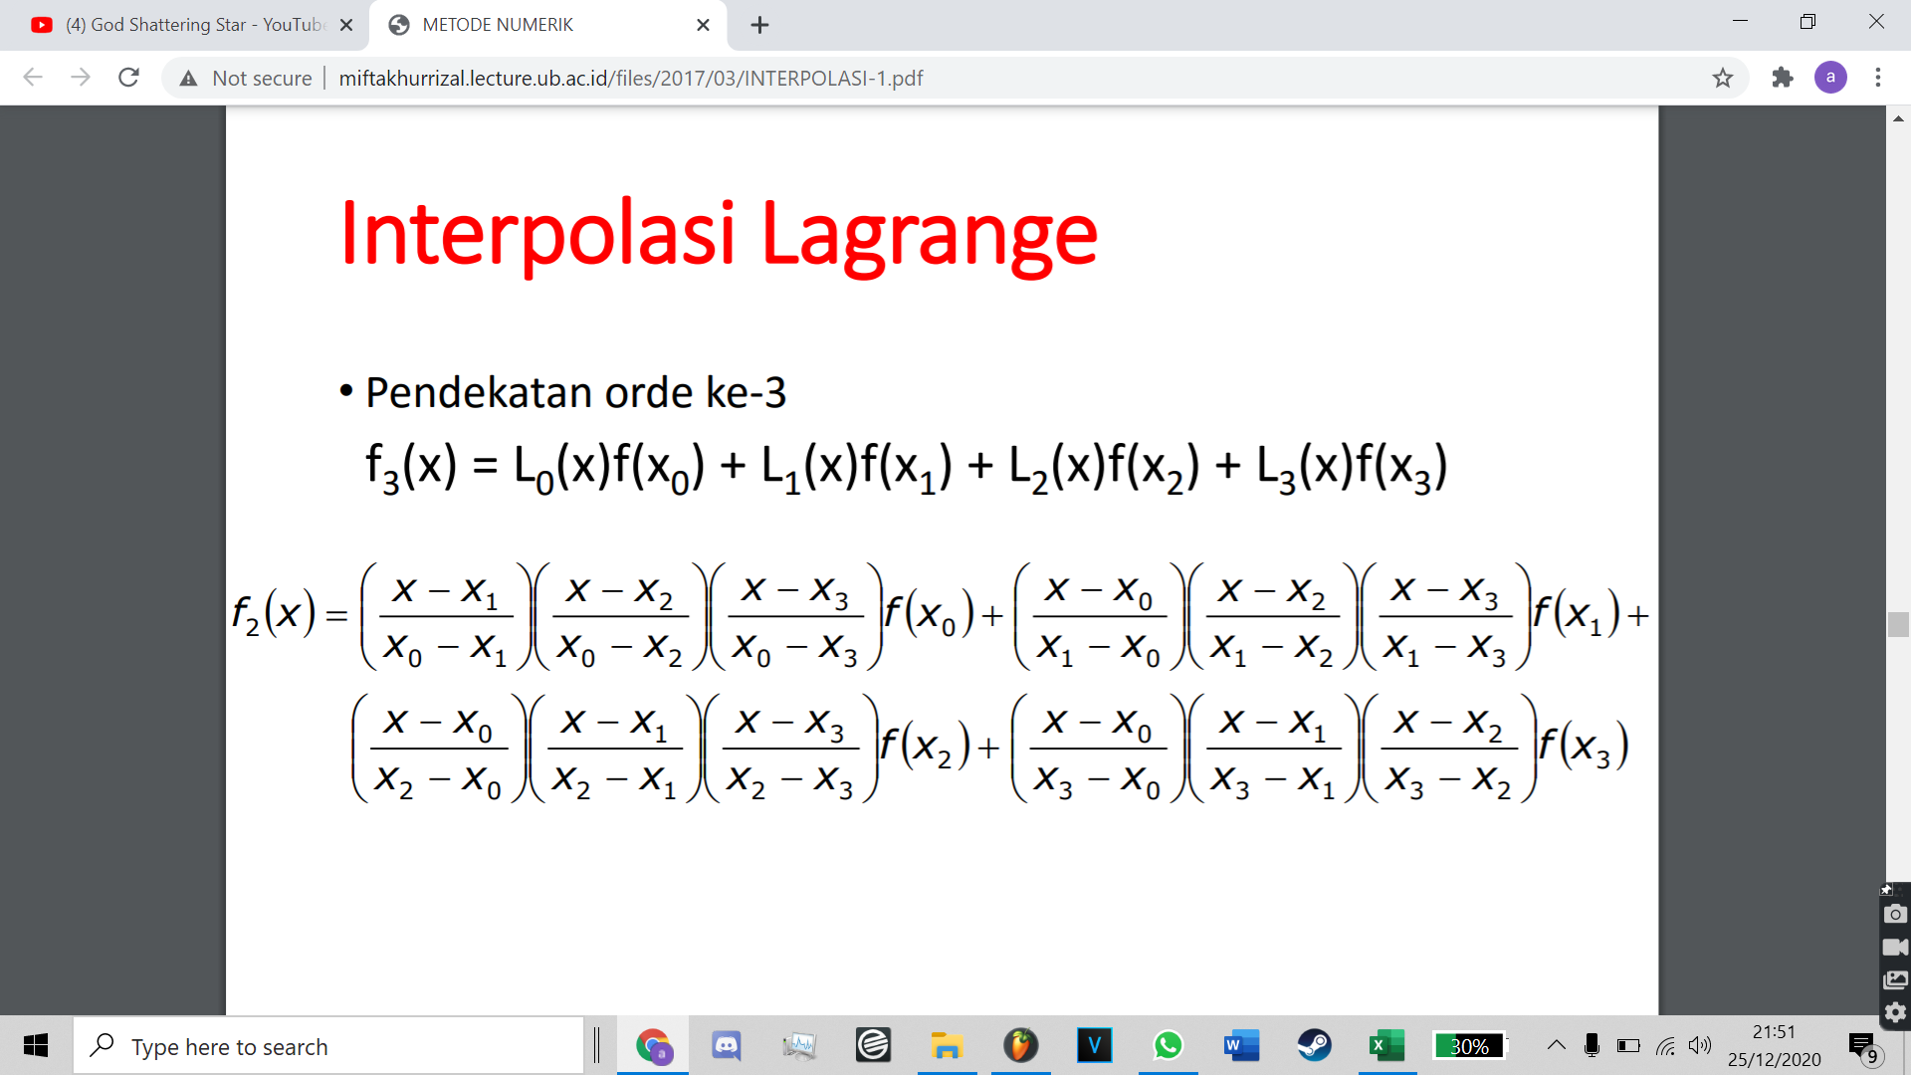

Kemudian didapatkan hasil sebagai berikut :

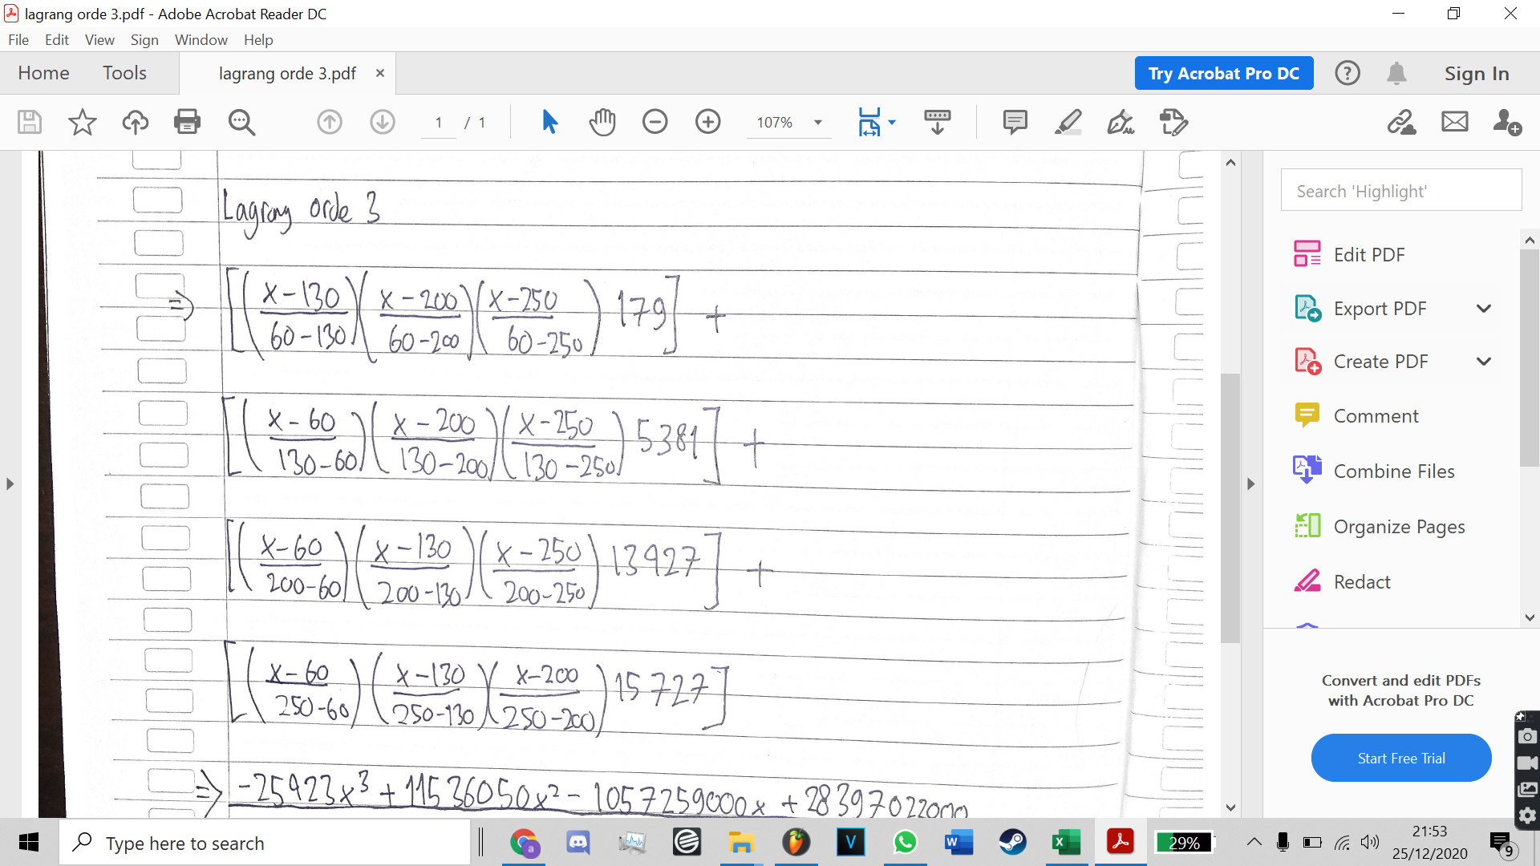

**F3(x) = (-25423x^3 + 11536050x^2 - 1057259000x + 28397022000) / 5586000)**

3. Metode Newton divide-difference

F(x) =

BAB 3 PENUTUP

3.1 Kesimpulan

3.2 Saran

DAFTAR PUSTAKA